**PART A**

**EXPERIMENT NO. 4**

**A.1 AIM: -** To understand linear programming.

**A.2 Prerequisite**

* Different programming language (Python or Java), Understanding of Machine Learning Algorithms, Machine Learning Algorithms

**A.3 Outcome**

After successful completion of this experiment students will be able to understand linear programming, solve problems related to linear programming.

**A.4 Theory**

**TORA SOFTWARE**

TORA Package is a computer application software package used for statistical computation and analysis. It is an already written program or suite of programs written for statistical application. It is basically applied for Operations Research (OR) analysis. TORA Optimization Window is a graphical user interface (GUI). This is what makes it unique from other statistical packages that have spreadsheets windows. Although, the input grid is edited much like spreadsheets, the number of rows and columns depend on setting. TORA is automated for screen display setting of 800 X 600 and 1024 X 768 pixels. The second setting is recommended because it produces a more proportionate layout of the screen.

**CAPABILITIES OF TORA**

TORA software offers modules for matrix inversion, solution of simultaneous linear equations, linear programming, transportation models, network models, project planning with CPM and PERT, queuing analysis, and game theory. TORA can be executed in automated or tutorial mode. The automated mode reports the final solution of the problem, usually in the standard format followed in commercial packages. The tutorial mode is a unique feature that provides immediate feedback to test the user’s understanding of the computation process and details of each algorithm. TORA is accessed in a logical and unambiguous manner, essentially eliminating the need for a user’s manual.

Excel spreadsheet templates complements TORA modules for operations research analysis. These templates includes linear programming, dynamic programming, analytical hierarchy process (AHP), Poisson queues, simulation, and nonlinear models. Some of the templates are direct spreadsheets

ADVANTAGES OF TORA

The TORA Optimization System is a Window-based software designed for use with many of the techniques presented in this article.

a. The system can be used to solve problems in a tutorial mode or automated mode. The tutorial mode is particularly useful because it allows concentration on the main concepts of the algorithms while relieving the user of the burden of the tedious computations that generally characterize Operation Research (OR) algorithm.

b. TORA is totally self-contained in the sense that all the instructions are represented by menus, commands buttons, check boxes and the likes.

c. It is user friendly and requires no user manual.

d. TORA is fast in calculations and analysis. Data which can take hours to compute or analyze manually, TORA will perform the computations in seconds.

e. As a computer program, if fed with correct data and appropriate commands, the results will be accurate and reliable.

f. TORA has an existing data file which contains set of data that you can read from if you don’t want to enter a new set of data.

YouTube link:

<https://www.youtube.com/watch?v=tX7hfO9Twx4>

<https://softwarewithrachit.blogspot.com/2020/05/tora-software-transportation-and-linear.html>

Example Solved for Task 2.1.

PROCEDURE:

Step 1: click to exe file of TORA, to open the software.

Step 2 : click linear programming problem.

Step 3: After click to linear programming a window is open (as shown). Click to

the “Go to the input screen”.

Step 4: After that write Problem Title, No. of Variable and No. of Constraint according to the given problem.

Step 5: A new window is open. Fill all column according to the problem. Such that fill column of Maximize or Minimize

and then constraint. And click to the Solve Now.

**A5. Task**

Perform Following Operations

1. Install TORA.
2. Implement the following using TORA software
3. linear programming problem using TORA software

Problem: A store sells men's and women's tennis shoes. It makes a profit of $1 per pair of men's shoes and $1.20 per pair of women's shoes. It takes two minutes of a salesperson's time and two minutes of a cashier's time to sell a pair of men's shoes. It takes three minutes of a salesperson's time and one minute of a cashier's time per pair of women's shoes. The store is open eight hours per day, during which time there are two salespersons and one cashier on duty. How many pairs of shoes of each type should the store sell in order to maximize profit each day?

1. QUEUING PROBLEM

A super market has two girls ringing up sales at the counters. If the service time from each customer is exponential with a mean of 4 minutes, and if people arrive in a Poisson fashion at the rate of 10 an hour, find

(a) what is the probability of having an arrival has to wait for service?

(b) What is the expected percentage of idle time for each girl?

1. SEQUENCING PROBLEM

Problem: We have five jobs each of which must go through two machines in the order BA, processing times are

given in the table below

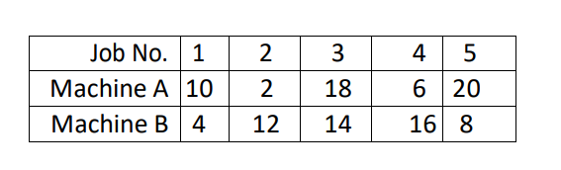

Determine a sequence for the five jobs that will minimize the total elapsed time. Also compute idle times for each of the

machine

PART B

|  |  |
| --- | --- |
| Roll No. C009 | Name: Samarth Borade |
| Class : BTI SEM 10 | Batch : EB1 |
| Date of Experiment: 16/02/24 | Date of Submission : |
| Grade : |  |

**B.1 Documentation written by student:**

Let *x* be the number of pairs of men's shoes and *y* be the number of pairs of women's shoes.

1. **Objective Function:**
   * Maximize Z = 1x + 1.2y
2. **Constraints:**
   * 2x + 3y ≤ 2 * 480 (Salesperson's time constraint)
   * 2x + y ≤ 480 (Cashier's time constraint)
   * x ≥ 0 (Non-negativity constraint for men's shoes)
   * y ≥ 0 (Non-negativity constraint for women's shoes)

The solution to the linear programming problem is as follows:

* The store should sell 120 pairs of men's shoes per day.
* The store should sell 240 pairs of women's shoes per day.

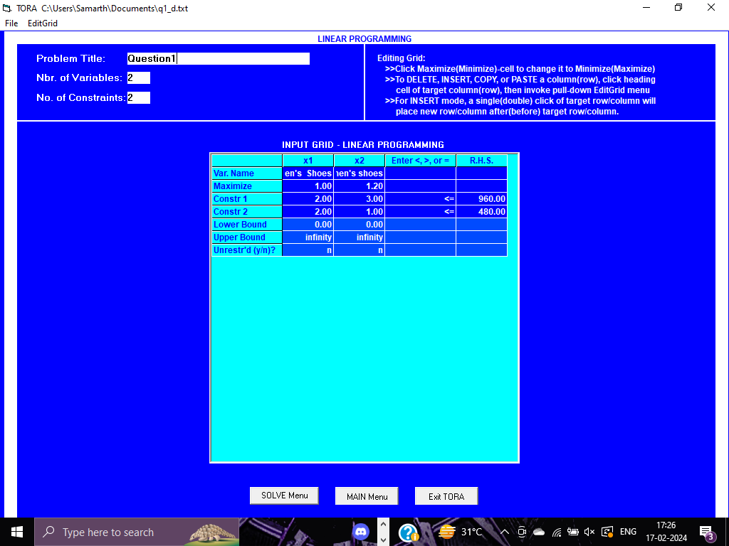

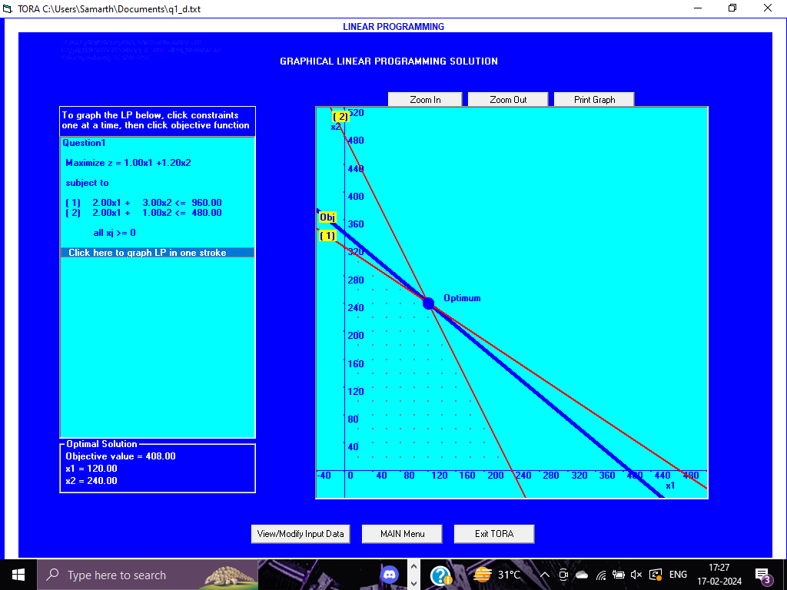

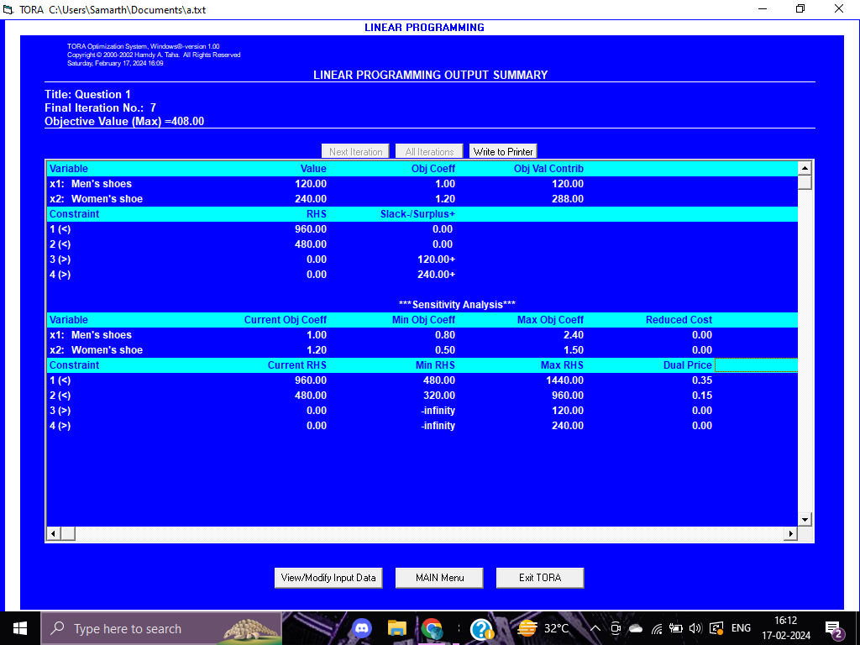

2 ) QUEUING PROBLEM

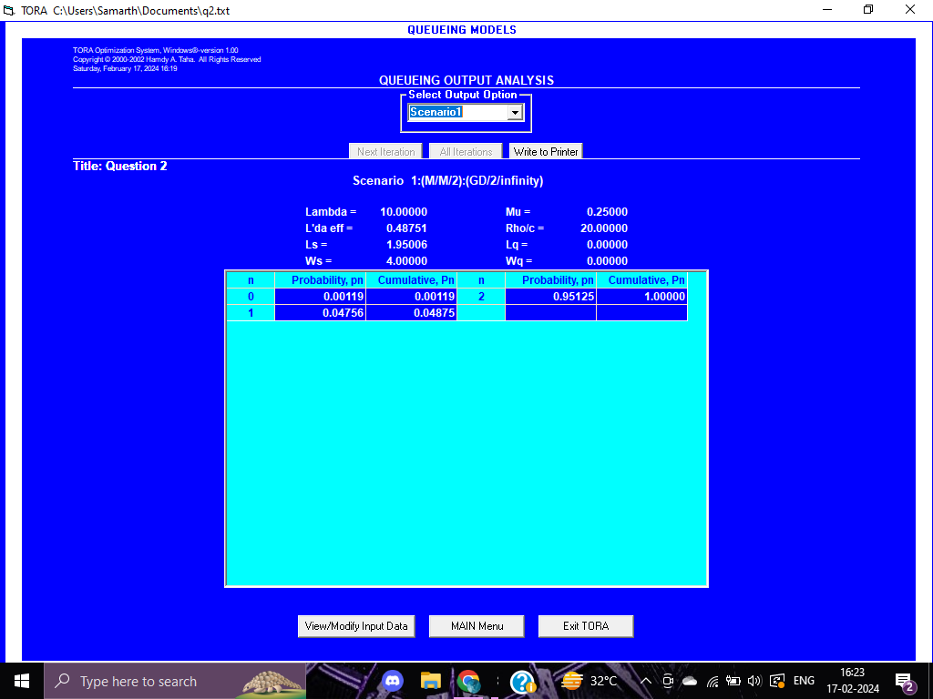

3) SEQUENCING PROBLEM

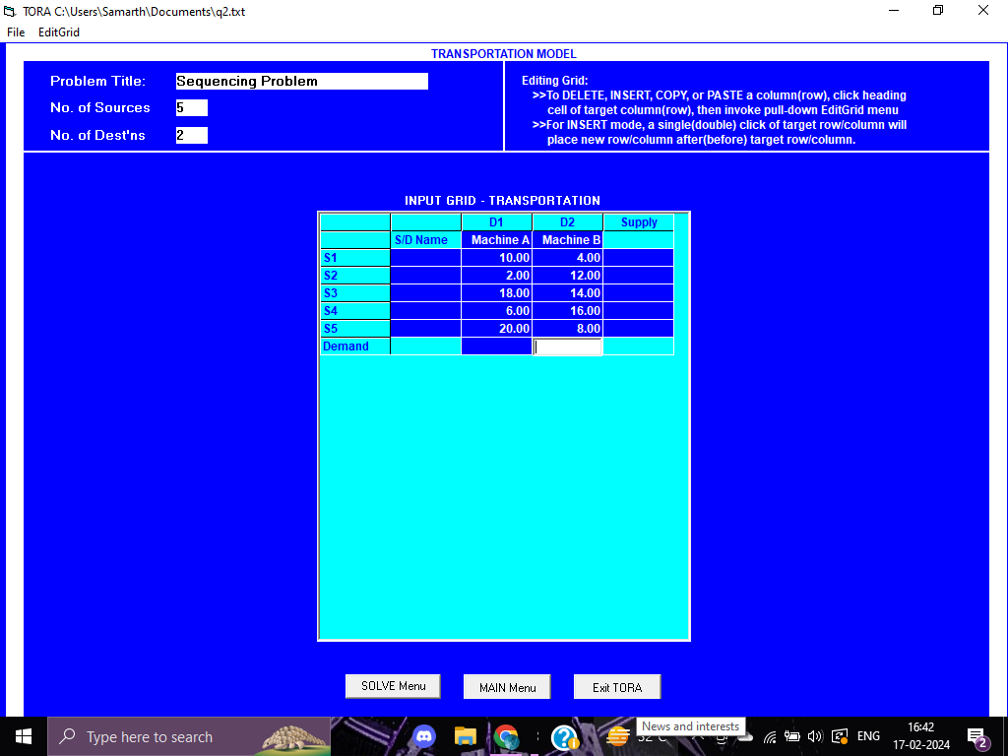

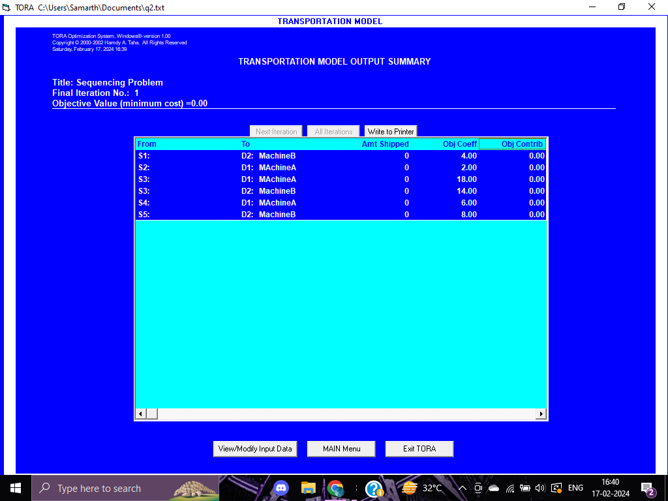

**B.2 Observations and learning:**

The Software seems old but it’s helpful in plotting and even find the answers to Linear Programming , queuing problems and sequencing problems too .

Using TORA software helped us analyze different operational problems like managing sales, handling customer queues, and optimizing job sequencing. We learned that making the most profit involves selling the right mix of products while considering resource limits. However, we noticed some issues in accurately predicting waiting times for customers. Also, when sequencing jobs, it's crucial to minimize time spent across different tasks. TORA proved useful for solving these challenges, but we need to make sure our input data is accurate for reliable results.

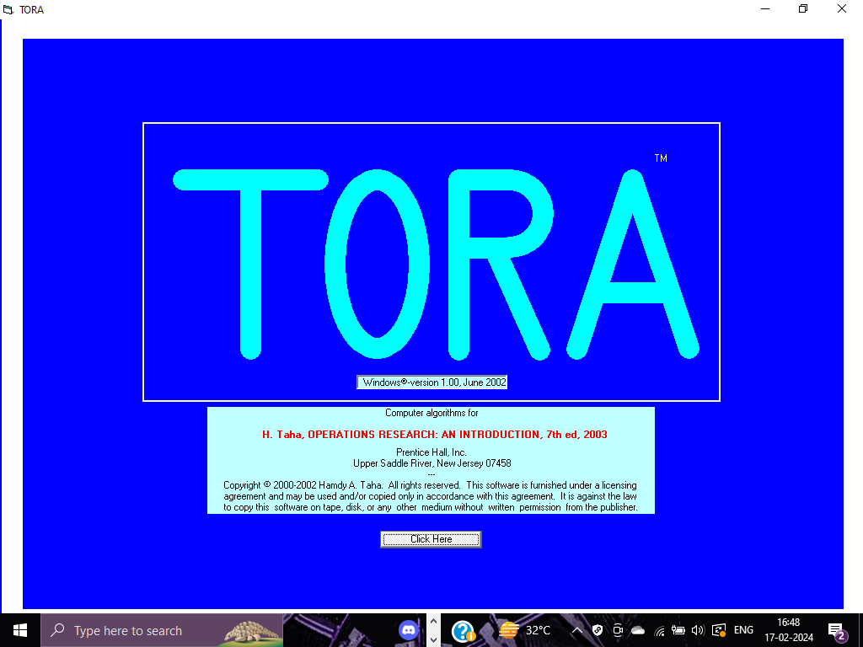

But I did face some problems regarding the queuing and sequencing problem.

**B.3 Conclusion:**

TORA software proved instrumental in analyzing operational challenges such as linear programming, queuing, and sequencing. It emphasized the importance of optimizing product mix for profit maximization while addressing resource constraints.

****************************